**Test Approach**

* + Created Rest Project using the WADL: Web Application Description Language:
    - <http://api.mathjs.org>
  + Created test suite and test case
  + Added following assertions

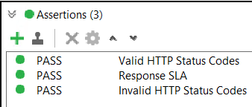

* + Executed test in sequence and in parallel
  + Added a Documentation to the project
    - <file:///C:/soapuidoc/wadl-report.html>



* + Added properties at Project, Suit, Case and Step level

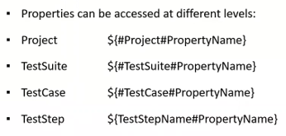

* + Performed Data Driven Testing Using Excel
  + Used Data Sink to **write results**

**Data**

* + Input Sample
    - 500 operations
  + Output
    - Attached in Division.xslx

**Result Overview**

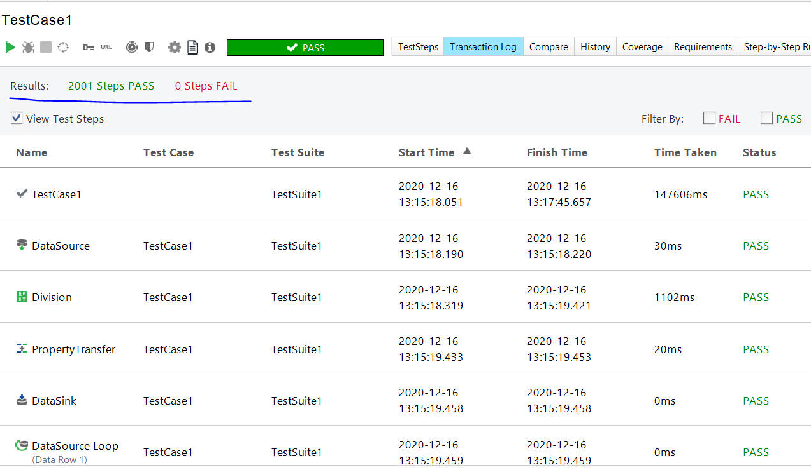

**Project Preview and folder structure**

* **With** Data driven testing

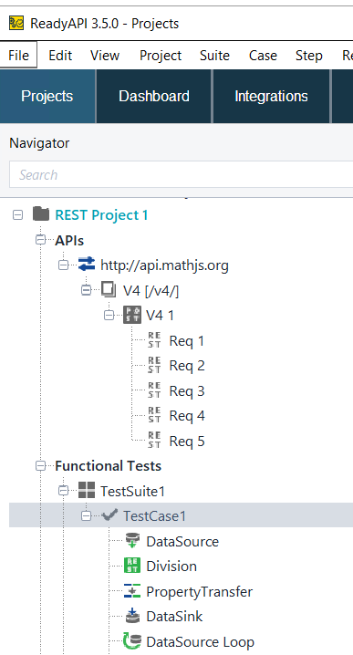

* **Without** Data driven testing

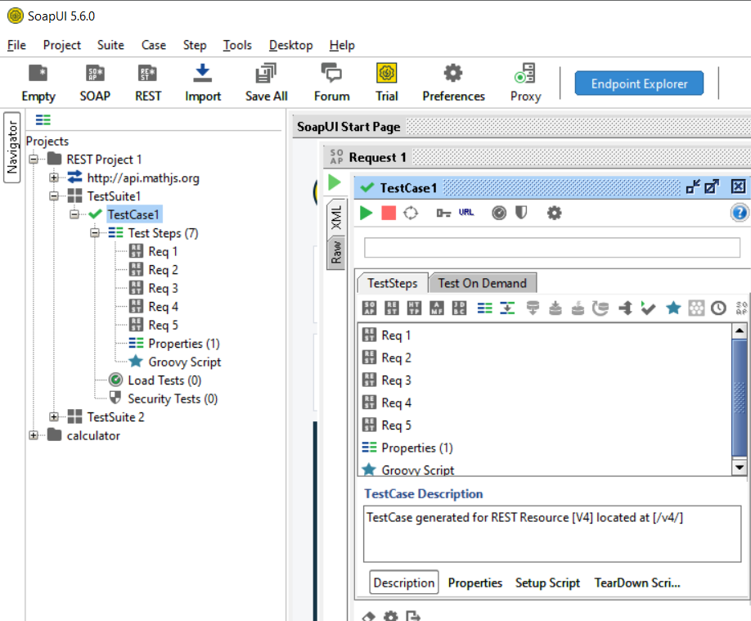

**Notes**

* + SW used: ReadyAPI 3.5.0
  + Tested using the following Regex in the Contains assertion:
    - ^[0-9] - To accept only numbers (0-9) and NO characters [duplicate]
    - ^[**0**-9](\.[**0**-9]+)?$ - To accept decimal numbers

**Supplementary Notes**

